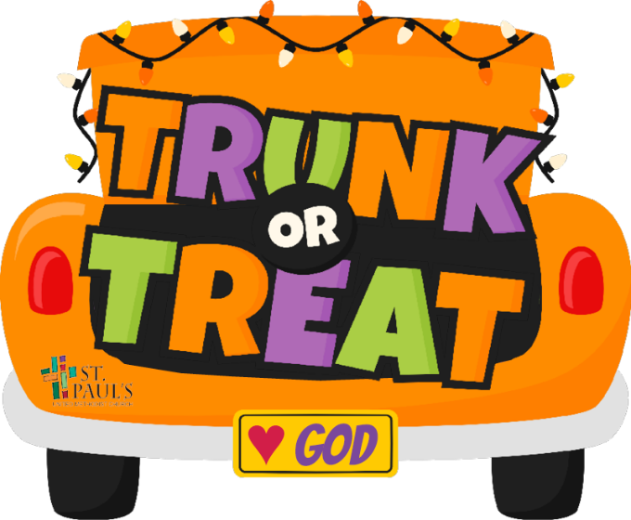
Providence
UMC

Rules and Guidelines:
Fall-o-Ween: October 20th from 4:30-6:00pm
- Any participating trunks, individually or with a team, must register before October 16th.
- Participating vehicles may arrive to 592 Bernhard Rd, front parking lot, starting at 3:30 pm.
- All participating vehicles must be parked, decorated and manned by 4:15 pm.
- For safety, vehicles arriving after 4:15 pm will not be able to participate.
- Each trunk must participate for the entire duration of the event and remained parked until 6:15 pm.
- Each trunk must have candy available to hand out.
- Electrical outlets will not be available.
- Please keep decorations and costumes fun, non-scary and family friendly. Decorations can be as elaborate or as simple as you wish. It is a competition. Check Pinterest or contact Madison for ideas!
- If interested in hosting a game with your trunk, please mark on the registration sheet. Trunks that are hosting a game will be in a different section than just decorated trunks. (Both are entered in the contest)
- This is a community event! Invite your friends, neighbors, or family. Please extend a warm welcome to all!
Once you have returned your registration form, you will be contacted with more information.
Contact Madison Busbee for any questions. 706-975-3448 or mbusbee@provumc.com
Please fill out registration form and return to Children’s Building before October 16th

Team/Family Name: ___________________________________________________

Type of Trunk (circle one): Car Van Truck Golf Cart SUV Other

Hosting a game? If yes, explain the game: __________________________________
Contact Person: _______________________________________________________

Email: _______________________________________________________________

If you would like to man a game, but not decorate a trunk, please fill out the Volunteer Form.

